20th Annual Kentuckiana Pro Am Summer League/Tournament
June 17 – 24
Beth Haven Christian School (5515 Johnsontown Rd. Louisville, Kentucky 40272)
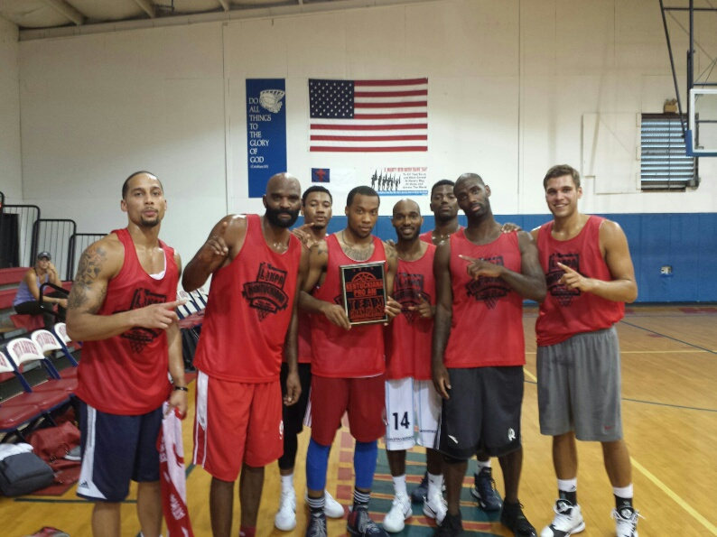
2015 Team Champions – Overseas Pros (Louisville, Kentucky)
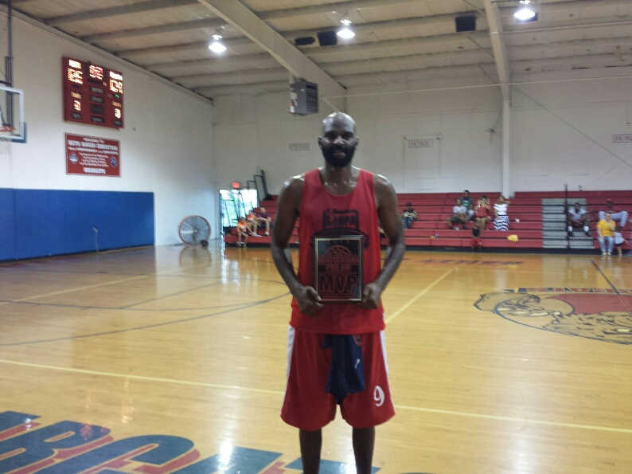
2015 KPA MVP – Nate Johnson (Louisville/Asia)
2016 KPA Schedule
Friday, June 17
6:30pm KPA Select 109 vs. First Care Dental 98
7:30pm Team Southern Indiana 77 vs. Team Havoc 86
8:30pm Free Agency Basketball 82 vs Kounty Boyz 78
Saturday, June 18
11:30am KPA Select #1 97 vs KPA Workout 86
Monday, June 20
7pm First Care Dental 85 vs. Team Havoc 69
8pm Kounty Boyz 100 vs. Team Southern Indiana 96
Tuesday, June 21
7pm First Care Dental vs. KPA Select #2
8pm Kounty Boyz vs. Team Southern Indiana
9pm KPA Select vs. Team Havoc
Wednesday, June 22 Tournament Begins/See Bracket also/Results CoachStinnett.com
7:00p.m. Team Havoc vs. Free Agency Basketball
8:00p.m. Overseas Pros vs. KPA Select #2
9:00pm Indy Young Gunz vs. First Care Dental
Thursday, June 23
7:00p.m. Akron Canton AM PRO vs. KPA Select #1
8:00p.m. Kounty Boyz vs. Winner of Overseas Pros vs. KPA Select #2
9:00p.m. Team Southern Indiana vs. Winner of Indy Young Gunz vs. FC Dental
Friday, June 24
6:30p.m. KPA Semi-Final Akron Canton AM PRO/KPA Select #1 Winner vs. Kounty Boyz vs. Overseas Pros/KPA Select #2 Winner
7:30p.m. KPA Semi-Final Team Havoc/Free Agency Winner vs. Team Southern Indiana vs Indy Young Gunz/FC Dental
9:00pm 20th Annual KPA Finals
10:00pm Naming of KPA All Tournament Team, 2016 MVP and Team Champs

2016 KPA Rosters
First Care Dental (Louisville, Kentucky)
Aaron Nance 6-3 Forward Louisville *2015 KPA All League
DeWhon McAfee 6-0 Guard Spalding
Tony Butler 6-5 Forward Louisville
Tirrell Weathers 5-10 Guard Lindsey Wilson
Vernon Payne 6-7 Forward IU Southeast
Robbie Simpson 6-10 Center Cheyney University
Cody Cutsinger 6-1 Guard Spalding
Dominque Sangester 6-0 Guard Spalding
Parker Henes 6-8 Forward IU Southeast

Kounty Boyz (Shelbyville, Kentucky)
AJ Slaughter 6-3 Guard Western Kentucky/Turkey *2015 All League
Donovan Johnson 6-6 Forward Kentucky Wesleyan/Argentina
Charles Foster 6-1 Guard Southern Indiana
Aaron Cosby 6-3 Guard Western Kentucky (2016)
Brian Stone 6-8 Forward Malone University (2016)
A’Darius Pegues 6-10 Forward Campbellsville/Mexico
Steffphon Pettigrew 6-7 Forward Western Kentucky/France
CJ Penny 6-6 Forward Asbury
Kyle Lamb 6-1 Guard Asbury
Robbie Simpson 6-10 Center Cheyney State

Overseas Pros (Louisville, Kentucky) *2015 KPA Champs
Peyton Siva 6-1 Guard Louisville/NBA/Italy *2015 All League
Chris Dowe 6-4 Guard Bellarmine/France *2015 All League
Jazz Ferguson 6-1 Guard IU Southeast/Italy *2015 All League
Nate Johnson 6-7 Forward Louisville/Asia *2015 KPA MVP
Larry O’Bannon 6-4 Guard Louisville/Argentina
Alhaji Mohammed 6-4 Guard Louisville/Romania
Keisten Jones 6-4 Guard Bellarmine/Germany
Leroy Hickerson 6-5 Forward Cumberland/Israel *2015 All League
Leroy Nobles 6-5 Guard IUPUI/Mexico
Rick Bodiford 6-4 Guard IU Southeast/Canada
Donta Smith 6-7 Forward SE Illinois JC/ NBA/Israel *2010 KPA MVP

Team Havoc (Louisville, Kentucky)
Carlos Mitchell 6-1 Guard IU Southeast/UBA
Will Richard 6-3 Guard Chile/UBA
Bradley Medley 6-5 Guard UBA
David Scott 6-8 Forward Miami Ohio/Argentina
Mac Wilkinson 6-9 Forward Louisville/Europe
Terrance Farley 6-10 Center Louisville/Europe/UBA
Sean Hampton 6-5 Forward Alderson Broaddus/Germany/UBA
Thomas Colemon 6-9 Forward North Carolina A&T/Uruguay
Robert Shaw 6-1 Guard Kentucky State
Ben Taylor 6-1 Guard Brigham Young

KPA Select #1
Jomari Bradshaw 6-6 Guard Florida A&M *2015 KPA All League
Tyrell Means 6-2 Guard IU Southeast/ABA
Corey Jackson 6-3 Guard Charleston University
Jermaine Jackson 6-4 Forward Florida Tech
Lafayette Jackson 6-0 Guard Boyce
Martez Dow 6-3 Forward IU Southeast
Quinton Horton 5-11 Guard St. Catherine/UBA
Brandon Williams 6-5 Forward Spalding
Free Agency Basketball
Lyonell Gaines 6-6 Forward Morehead State (2016)
Chris Johnson 6-3 Guard St. Catherine (2016)
Darius Gibson 6-2 Guard Samford (2016)
Remy Abell 6-4 Guard Xavier (2016)
Marcellus Barksdale 6-5 Guard IUPUI (2016)
Treg Setty 6-9 Forward Ohio University (2016)
Deondre McWhorter 6-8 Forward Georgetown College
Brent Arrington 6-3 Guard Morehead State (2016)
Andrew Mitchell 5-11 Guard Kent State
Akron Canton Am Pro (Ohio) *Vance Marbury Director
Mike Porrini 6-2 Guard Kent State/Europe
Nick Harney 6-8 Forward Fairmont State
Trey Howard 6-3 Guard Lake Erie (2016)
Mario Edwards 6-3 Guard Coastal Carolina (2016)
Jesse Hardin 6-2 Guard Walsh (2016)
Brett McKnight 6-6 Forward Akron/Columbus (CBA)
Victor Dorsey 6-9 Forward Longwood (2016)
Darrell Parker 6-2 Guard Cuyahoga CC
Team Southern Indiana *2014 KPA Champs (Matt Dennison Hoosier Hill Hoops)
Tenale Roland 6-0 Guard Southern Indiana/Cyprus *2015 KPA All League
Vance Hall 6-4 Guard Bellarmine/Iceland *2015 KPA All League
Danny Gibson 5-10 Guard Poland *2015 KPA All League
Josh Derksen 6-9 Forward Kentucky Wesleyan
Bo Harris 6-8 Forward Mountain State
Mike Jones 6-0 Guard Boyce College
Chase Spreen 6-6 Forward Lindsey Wilson/Bowling Green Hornets
Erik Daniels 6-9 Forward Kentucky/NBA/Argentina
Shelvin Mack 6-3 Guard Butler/NBA Utah Jazz

Indy Young Gunz (Indianapolis Indiana) Damon White
Brandon Beasley 6-5 G/F William Penn/Luxenbourg
Greg Foster 6-2 G Saginaw Valley/Ft. Wayne CBA
David Logan 6-1 G Indianapolis/Italy *2 Time KPA Champion
Deonte Vaughn 6-1 G Cincinnati/France
Julian Mavunga 6-8 F Miami Ohio/Japan
Antonio Ballard 6-5 F Miami Ohio/France
Aaron Hogg 6-6 F Wichita State/Indiana Diesel
Corey Wickward 5-10 G SIU Edwardsville/Ft. Wayne CBA
Joe Lawson 6-7 F Indianapolis/Germany

KPA Select #2
Jalen Wesson Palm 5-10 G Trevecca Nazerene (16)
Ian Chiles 6-3 G Tennessee
Devan Crain 6-0 G Kentucky State
Tryston Ford 5-10 G Kentucky State (160
Antone Miller 5-10 G ECTC
Deantra Scott 6-5 F Lindsey Wilson/Bowling Green Hornets
Tamron Manning 6-5 G/F Kentucky Wesleyan (2016)
Tony Kimbro Jr. 6-5 G Georgetown/2015 KPA College Player of the Year
Markus Montague 6-9 F Kentucky State/Malta/Senegal

2016 KPA Championship Game Results
OVERSEAS PROS 126 KPA #1 104 Leroy Nobles led OP with 28 (8 3's) and KPA MVP Nate Johnson had 26. Aaron Nance led KPA #1 with 45 and 11 3's. Overseas Pros - Leroy Nobles 28, Nate Johnson 26,Rick Bodiford 22, Leroy Hickerson 21, Jake Thelen 10, Keisten Jones 8, Chris Dowe 8, Jazz Ferguson 3 KPA #1 Aaron Nance 45, Jomari Bradshaw 23, Orlando Rutledge 20, Vance Hall 10, Ulysses Thomas 4, Brian Boerner 2

2015 KPA MVP/All League Team
MVP – Nate Johnson (Louisville/Asia)
All League – Jazz Ferguson (IU Southeast/Italy), AJ Slaughter (Western Kentucky/Turkey), Chris Dowe (Bellarmine/France/Belgium), Peyton Siva (Louisville/NBA/Italy/Germany), Leroy Hickerson (Cumberland Tn./Israel), Aaron Nance (Louisville Football), Vance Hall (Bellarmine/Iceland/Germany), Jomari Bradshaw (Florida A&M), Jake Simpson (IU Southeast), Danny Gibson (Southern Indiana/Poland), Tenale Roland (Southern Indiana/Cyprus), Danny Gibson (Southern Indiana/Poland), Chris Whitehead (Bellarmine/Australia), Current College Player of the Year – Tony Kimbro (Georgetown

